

**Ultra USB**



**Name: SanDisk Type C Ultra USB Dual Drive 3.1 - OTG - 64GB - 1 Year Warranty**

**Price:** Rs. 3,500

**Product details of SanDisk Type C Ultra USB Dual Drive 3.1 - OTG - 64GB - 1 Year Warranty**

* 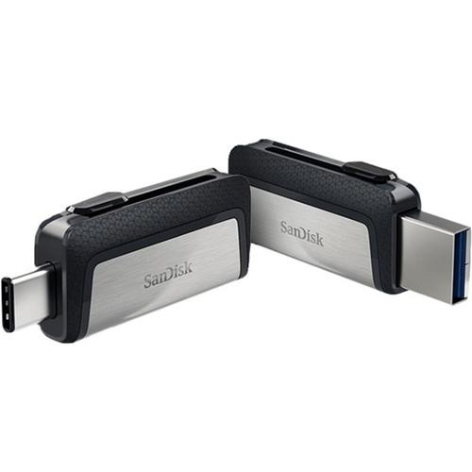Interface
* USB Type-C and USB Type-A connectors; USB 3.1 (Gen 1)
* Operational temperature
* 32° - 113° F (0° – 45° C)
* Storage temperature
* 14° - 158° F (-10° – 70° C)
* Dimensions
* 9.4 x 38.10 x 20.07 mm ; 0.37 x 1.50 x 0.79 in
* Weight
* 9.1 g ; 0.02 lbs.
* PC/Mac computer compatibility
* Windows Vista®, Windows®7, Windows 8, Windows 10, Mac OS X v10.6 and higher
* Mobile device compatibility
* Smartphones, tablets, and other host devices with USB Type-C™ ports and On-The-Go (OTG) support. See www.sandisk.com/dualdrive-c for list of compatible devices.